Employment Opportunity

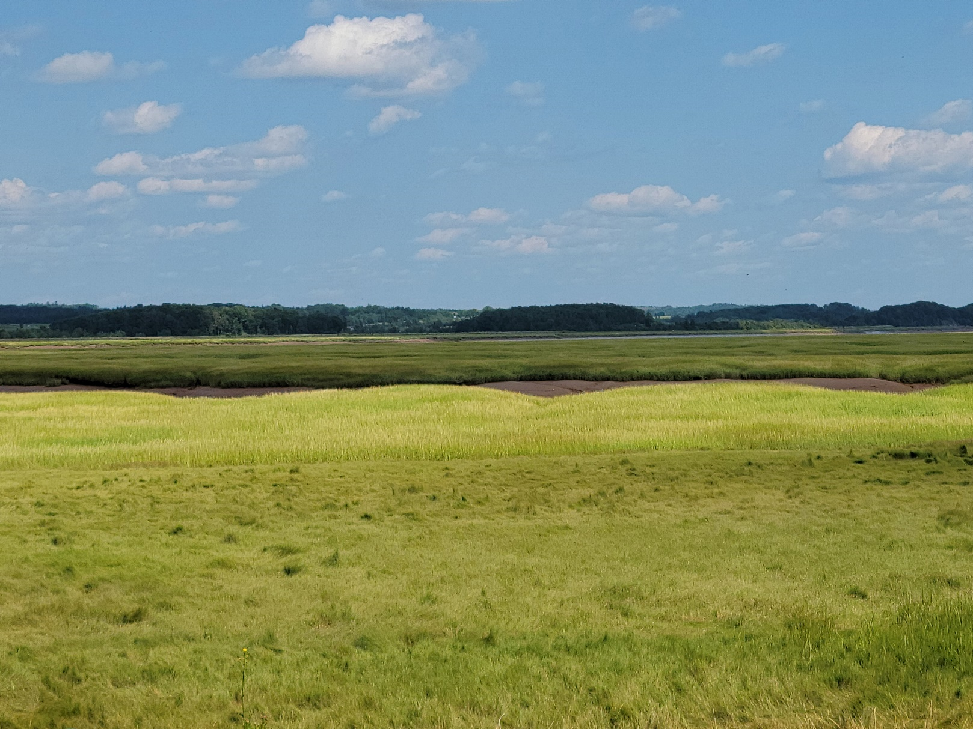

**POSTION:** Consultation Support Officer

**LOCATION:** Flexible within Nova Scotia

**TERM**: To October 2, 2023

**CLOSING DATE:** January 22, 2023

**JOB SUMMARY**

Kwilmu’kw Maw-klusuaqn Negotiation Office (KMK) supports the Assembly of Nova Scotia Mi’kmaw Chiefs (Assembly) in the negotiation and consultation processes. KMK engages Nova Scotia Mi’kmaw communities on the best ways to implement our collective Aboriginal and Treaty Rights. KMK is seeking a **Consultation Support Officer** for a term role.

**DUTIES AND RESPONSIBILTIES**

* Assist with the development and implementation of projects - including project plans, policies and solutions and contributes to issue resolution and escalation, research, analysis activities and planning and monitoring activities
* Provide Mi’kmaq leadership with detailed and researched information to make decisions
* Drafting communication in regard to educational material, correspondence, ministry briefings and reporting
* Communicate with Mi’kmaq community members about information on Consultation projects
* Produce regular reports as requested
* Perform other related duties as requested
* Travel within the province will be required

**QUALIFICATIONS**

* Degree in Business, Environmental Science, Biology, Geology, or a related field or equivalent experience
* Knowledge of the Provincial and Federal Environmental Assessment Acts
* Knowledge of Mi’kmaq Traditions, culture and of the Nova Scotia Mi’kmaq communities
* Strong understanding of and ability to review technical information
* Knowledge of Mi’kmaq Traditional Use and Mi’kmaq Rights
* Experience collecting data, defining problems, fact finding, and drawing valid conclusions to support Mi’kmaq rights
* Strong interpersonal, written communication and organization skills
* Proficient in the use of Microsoft Office programs
* Ability to review and analyze Federal or Provincial Environmental Assessments
* Advocate for issues of concern for the Mi’kmaq of Nova Scotia
* Ability to balance priorities and consistently meet deadlines

**CONDITIONS OF EMPLOYMENT**

* Must hold and maintain a valid NS driver’s license. Travel throughout Nova Scotia will be required.
* Potential for occasional work on weekends or evenings.

**__________________________________________________________________________**

**Applications will not be accepted without a cover letter and resume.**

**Applications must be received by 11:59pm on the closing date and can be emailed to: CAREERS@MIKMAQRIGHTS.COM**

Kwilmu’kw Maw-klusuaqn hires on the basis of merit and is committed to employment equity. We encourage all qualified persons to apply; however, qualified Aboriginal applicants will be given priority in accordance with the Aboriginal Employment Preference policy of the Canadian Human Rights Commission.

**Please note that only those selected for further consideration will be contacted.**